Существующие таблицы:
USE Sport;
GO

SELECT * FROM Users;
SELECT * FROM Programs;
SELECT * FROM Exercises;
SELECT * FROM MuscleGroups;
SELECT * FROM ExerciseMuscleGroups;
SELECT * FROM Activities;
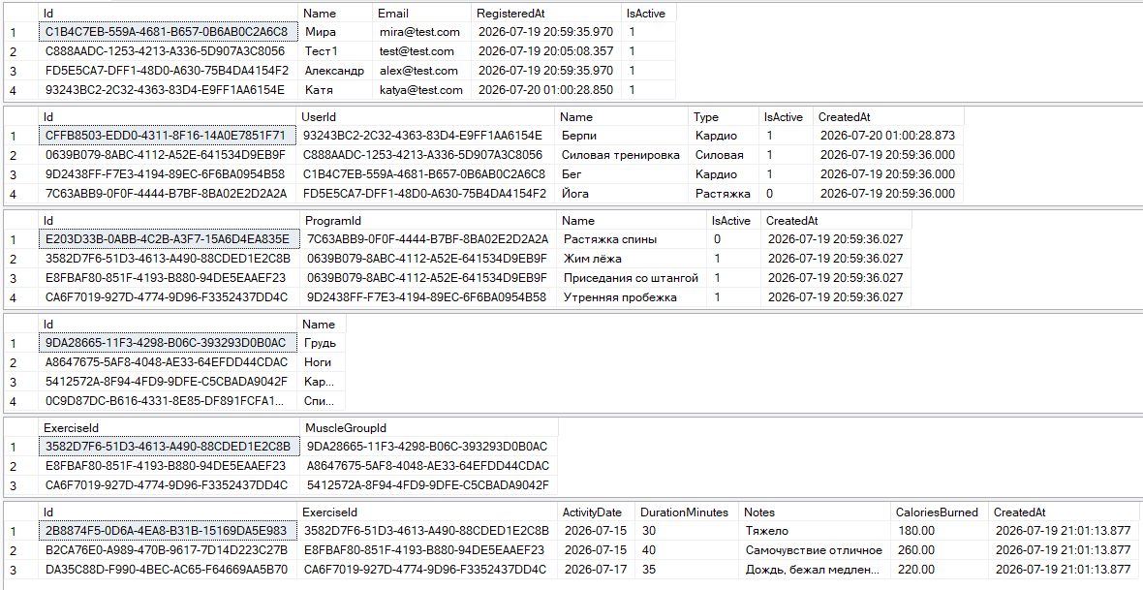
1. Выборка данных с фильтрацией, сортировкой
USE Sport;
GO
-- Активности более 30 минут. Сортировка по дате (сначала новые)
SELECT Id, ActivityDate, DurationMinutes, Notes, CaloriesBurned
FROM Activities
WHERE DurationMinutes > 30
ORDER BY ActivityDate DESC;
GO
2. Удаление, изменение данных
USE Sport;
GO

UPDATE Activities
SET CaloriesBurned = 260.0,
Notes = N'Самочувствие отличное'
WHERE ActivityDate = '2026-07-15' AND DurationMinutes = 40;
GO

SELECT * FROM Activities WHERE ActivityDate = '2026-07-15' AND DurationMinutes = 40;
GO

DELETE FROM Activities
WHERE DurationMinutes = 25;
GO

SELECT * FROM Activities;
GO
ДО
ПОСЛЕ 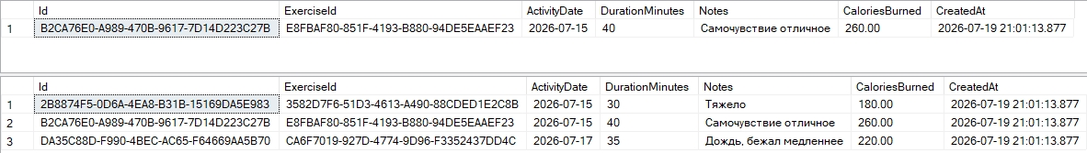

3. Выборка с группировкой
USE Sport;
GO

--Показывает сколько упражнений в каждой программе
SELECT
p.Name AS Программа,
COUNT(e.Id) AS КоличествоУпражнений
FROM Programs p
LEFT JOIN Exercises e ON e.ProgramId = p.Id
GROUP BY p.Name
ORDER BY КоличествоУпражнений DESC;
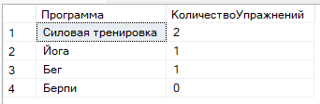
4. Выборка из нескольких связанных таблиц (левое, правое соединение, пересечение)
USE Sport;
GO

SELECT p.Name AS Программа, e.Name AS Упражнение
FROM Programs p
INNER JOIN Exercises e ON e.ProgramId = p.Id;
GO

SELECT p.Name AS Программа, e.Name AS Упражнение
FROM Programs p
LEFT JOIN Exercises e ON e.ProgramId = p.Id;
GO

SELECT e.Name AS Упражнение, mg.Name AS ГруппаМышц
FROM Exercises e
JOIN ExerciseMuscleGroups emg ON emg.ExerciseId = e.Id
RIGHT JOIN MuscleGroups mg ON mg.Id = emg.MuscleGroupId
ORDER BY mg.Name;
GO
